GLOW LOGICS DIGITAL MARKETING
A PROJECT ON
INFLENCER MARKETING STRATEGY FOR A HEALTH SUPPLEMENT BRAND
Bachelor of Science in AI&DS
Ⅱ YEAR B.Sc – (AI&DS)
Submitted by,
S.ARAVINDH (Reg.No:12225050010)
DEPARTMENT OF SCIENCE

DHANALAKSHMI SRINIVASAN UNIVERSITY SCHOOL OF ARTS & SCIENCE
SAMAYAPURAM,TRICHY- 621112.

SEPTEMBER- 2026

CERTIFICATE

This is to certify that the project titled “Influencer Marketing Strategy for a Health Supplement Brand” is a structured academic study of influencer-led digital marketing. The project examines strategy formulation, creator selection, content planning, campaign execution, measurement, risk management and ethical communication for a hypothetical health supplement brand.

Particular | Details
Project title | Influencer Marketing Strategy for a Health  Supplement Brand
Project type | Marketing Strategy Project
Study area | Digital Marketing / Influencer Marketing
Reference period | 2026
Brand context | Hypothetical health supplement brand

Date:30.09.2026

DECLARATION

I declare that this project report has been prepared for academic purposes and presents an original strategic framework for influencer marketing in the health supplement category. The brand used in the project is hypothetical unless otherwise stated. The recommendations are presented as marketing strategy concepts and are not medical advice.
The project uses secondary concepts from digital marketing, consumer behaviour, creator marketing and responsible health communication. Any illustrative numbers, dashboards and campaign metrics are hypothetical and are intended to demonstrate planning and measurement methods rather than represent actual brand performance.

Name: S.ARAVINDH Date: 30.09.2026

ACKNOWLEDGEMENT
I would like to express my appreciation to everyone who contributed guidance and support to the completion of this project. The project combines principles of marketing strategy, social media communication, consumer psychology, creator partnerships and performance analytics.
Special thanks are due to the faculty / mentor for guidance on structuring the project and to the wider digital marketing ecosystem for providing practical frameworks through which influencer campaigns can be planned and evaluated.
The report also recognises the importance of responsible communication in the health supplement category. Because supplement decisions can affect consumer wellbeing, the strategy emphasises transparency, evidence-aware messaging, clear disclosures and avoidance of exaggerated health claims.

EXECUTIVE SUMMARY
Influencer marketing has developed from celebrity endorsement into a broader creator ecosystem involving macro, micro and niche creators. For a health supplement brand, the opportunity is not simply to purchase reach; it is to build credible education, demonstrate product use responsibly and guide audiences through a measurable journey from awareness to trial and repeat purchase.
This project proposes an end-to-end influencer marketing strategy. It begins with business objectives and audience segmentation, moves through creator discovery and due diligence, and then connects content formats with campaign stages. Measurement covers reach, engagement, traffic, conversions, customer acquisition cost, return on marketing investment and qualitative indicators such as comment quality and trust signals.
The strategy uses a hypothetical brand named “VitaCore” only for illustration. It does not make medical efficacy claims. Product communication should be based on substantiated, legally permissible claims and reviewed before publication.
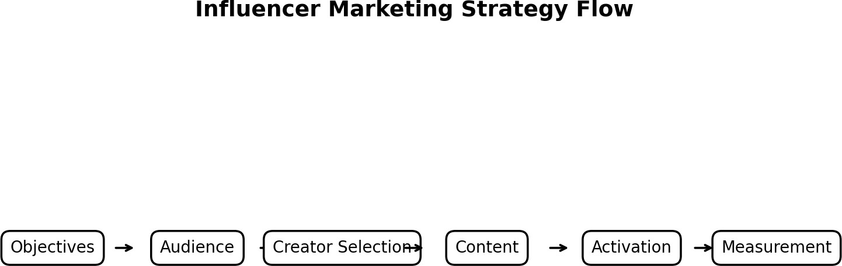

TABLE OF CONTENTS
Project structure

No. | Section | Page
1 | Introduction | 1
2 | Need and significant of  the study | 2
3 | Objectives of the  project | 3
4 | Target audience  analysis | 4
5 | Customer Personas | 5
6 | Customer Journey | 6
7 | Influencer marketing in  the health category | 7
8 | Competitive analysis  framework | 8
9 | Swot analysis | 9
10 | Brand positioning | 10
11 | Creator taxonomy | 11
12 | Creator selection  scorecard | 12
13 | Creator due diligence | 13

14 | Content pillars | 14
15 | Content format strategy | 15
16 | Campaign architecture | 16
17 | Campaign phases | 17
18 | Influencer brief  template | 18
19 | Creator outreach & relationship management | 19
20 | Storytelling framework | 20
21 | Disclosure & compliance framework | 21
22 | Health claims  management | 22
23 | Measurement  framework | 23
24 | KPI dashboard | 24
25 | Budget allocation | 25
26 | ROI & unit economics | 26
27 | Tools & technology  stack | 27
28 | Risk management | 28
29 | Ethical considerations | 29
30 | 90-day implementation plan | 30
31 | Sample campaign  concept | 31
32 | Expected outcomes &  learning agenda | 32
33 | Conclusion | 33

INFLUENCER MARKETING STRATEGY FOR A HEALTH SUPPLEMENT BRAND

Introduction
↓
Influencer marketing helps a health supplement brand reach relevant consumers through trusted and relatable creators while communicating product information in an engaging and responsible way.
↓

Brand Objectives
↓
The brand first identifies its objectives, such as increasing awareness, building trust, generating product trials, increasing sales and developing long-term customer relationships.
↓

Target Audience
↓
The brand identifies its target consumers based on their age, lifestyle, interests, needs, purchasing behaviour and preferred social media platforms.
↓

Customer Analysis
↓
Consumer needs, motivations, doubts and purchase barriers are studied to understand what type of information and content will influence their decision-making.
↓

Influencer Selection
↓
Suitable influencers are selected according to audience relevance, credibility, engagement quality, content style, brand suitability and previous campaign performance rather than follower count alone.
↓

Influencer Due Diligence
↓
The brand reviews the influencer’s previous content, audience quality, sponsorship history, brand collaborations and potential reputation or compliance risks before partnership.
↓

Content Strategy
↓
Influencers create educational, lifestyle, product-demonstration, ingredient-explanation, routine-based and promotional content that matches the brand message and audience interests.
↓

Campaign Execution
↓
The campaign is launched through selected social media platforms using planned posts, reels, stories, videos, live sessions, links, promotional codes and suitable calls to action.
↓

Audience Engagement
↓
Consumers interact with influencer content through views, likes, comments, shares, saves, questions and website visits, helping the brand build awareness and consideration.
↓

Conversion
↓
Interested consumers are encouraged to visit the product page, learn more about the supplement, use a campaign code or make a purchase.
↓

Measurement & KPIs
↓
Campaign performance is measured using reach, impressions, engagement rate, clicks, conversion rate, customer acquisition cost, revenue and return on marketing investment.
↓

Compliance & Ethics
↓
The brand ensures clear sponsorship disclosure, accurate product information, responsible health communication and avoids unsupported, exaggerated or guaranteed health claims.
↓

Risk Management
↓
Potential risks such as misleading claims, fake engagement, creator controversies, negative comments and platform changes are identified and managed through proper guidelines.

↓

Optimisation
↓
Campaign results are analysed to identify successful influencers, content formats, messages and calls to action, and these findings are used to improve future campaigns.
↓

Conclusion
↓
A successful influencer marketing strategy for a health supplement brand combines the right audience, suitable influencers, valuable content, responsible communication and continuous performance measurement to create sustainable brand growth and consumer trust.

INTRODUCTION

Influencer marketing refers to the use of people who have established audiences and perceived expertise, relatability or cultural relevance to communicate a brand message. The modern creator economy includes social personalities, subject-matter educators, fitness creators, nutrition communicators, lifestyle creators and community leaders.
For health supplements, influencer marketing requires additional care. Consumers may interpret personal stories as evidence of product effectiveness, even when an influencer is only describing an experience. Therefore, a sound strategy separates personal experience, product information and health claims, while providing transparent sponsorship disclosure.
The objective of this project is to create a practical strategy that a hypothetical health supplement brand can use to plan, execute and measure creator campaigns while maintaining
responsible communication.

NEED AND SIGNIFICANCE OF THE STUDY

The health supplement market is information-intensive. Consumers encounter product claims through search engines, marketplaces, social media, communities and personal recommendations. Influencers can simplify complex information, demonstrate routines and answer common questions, but they can also amplify misinformation if campaigns are poorly governed.
- Build brand awareness in relevant digital communities.

- Translate product features into understandable, consumer-friendly content.

- Create repeatable creator partnerships rather than isolated sponsored posts.

- Connect creator activity to measurable business outcomes.

- Develop a governance system for disclosures, claims and content approvals.

- Use audience feedback to improve future campaigns.

The significance of the study lies in integrating brand strategy and creator strategy. Instead of treating influencers as an advertising placement, the framework treats them as partners within a wider customer journey.

OBJECTIVES OF THE PROJECT

Objective | Strategic meaning | Measurement examples
Awareness | Increase qualified exposure among target audiences | Reach, impressions, video views
Trust & education | Provide understandable product information | Saves, shares, positive comments
Consideration | Move interested viewers to product pages | CTR, landing-page visits
Trial | Generate measurable first purchases | Conversions, CPA
Retention | Encourage appropriate repeat purchase behaviour | Repeat rate, cohort revenue
Learning | Identify creator/content patterns that work | Performance by creator and format

The objectives should be converted into campaign-specific targets after historical performance, media costs, product economics and platform benchmarks are available. Illustrative metrics in this report are not forecasts.

TARGET AUDIENCE ANALYSIS

Audience segmentation should be based on needs, motivations, behaviours and content consumption patterns rather than age alone. A supplement brand may serve several distinct use cases, and each should receive relevant content without implying that a product treats or prevents disease.

Segment | Need state | Content preference | Strategic role
Wellness beginners | Simple routines | Short explainers | Awareness
Active lifestyle users | Routine convenience | Demonstrations | Consideration
Busy professionals | Convenience & consistency | Practical tips | Trial
Ingredient-conscious users | Transparency | Ingredient explainers | Trust
Existing customers | Usage support | Routine/community content | Retention

Audience research should also identify questions, objections, purchase barriers, preferred creators, platform behaviour and sensitivity to promotional content.

CUSTOMER PERSONAS
Personas help translate segmentation into creative briefs. They should remain evidence-based and be revised when first-party data or campaign results reveal different behaviour.

Personas | Profile | Barrier | Influencer angle
The Starter | Wants a simple wellness routine | Information overload | Beginner-friendly routine
The Researcher | Reads labels and compares options | Trust and proof | Ingredient transparency
The Routine Builder | Values consistency | Forgets or loses motivation | Habit and routine content
The Community Seeker | Looks for relatable experiences | Feels unsure alone | Community Q&A / live session

A creator brief should not ask an influencer to impersonate a medical professional. Where health expertise is genuinely needed, qualified professionals can be involved for educational content, with appropriate review.

CUSTOMER JOURNEY

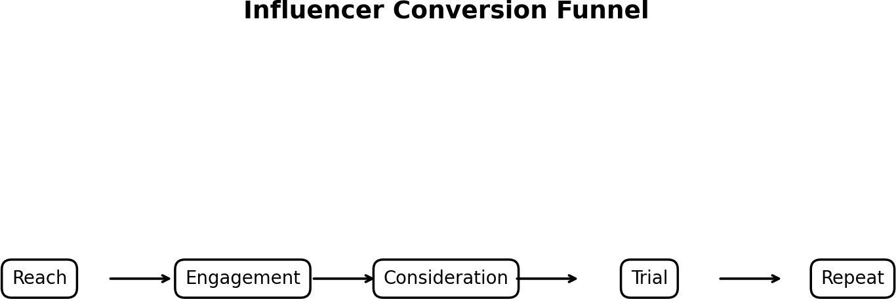

The journey begins with attention and progresses through engagement, consideration, trial and repeat behaviour. Different creators and content formats can play different roles at each stage. For example, a broad lifestyle creator may generate discovery, while a niche educator may help explain ingredients and a community creator may support consideration.
Attribution should recognise that a customer may encounter several touchpoints before purchase. Discount codes, unique links, landing pages, post-purchase surveys and platform analytics can be combined to create a more complete measurement picture.

INFLUENCER MARKETING IN THE HEALTH CATEGORY
Health-related influencer campaigns operate at the intersection of advertising, consumer trust and public information. The central strategic challenge is balancing persuasive storytelling with factual accuracy.
- Personal testimonials can create relatability but should not be presented as universal outcomes.

- Educational content can reduce confusion when it is clear, accurate and appropriately qualified.

- Creator fit is often more important than follower count alone.

- Comments and community discussions can reveal objections that conventional ad reporting misses.

- Paid partnerships should be clearly identifiable to the audience.

- Claims must be reviewed against applicable laws, platform rules and product evidence.

The brand should maintain a documented claims library and approval process before scaling creator activity.

COMPETITIVE ANALYSIS FRAMEWORK
A useful competitor review does not only count sponsored posts. It examines positioning, creator types, recurring messages, content formats, offer structures, audience reactions and potential white spaces.

Dimension | Questions to analyse
Positioning | What consumer problem or lifestyle context is emphasised?
Creators | Which creator categories are repeatedly used?
Content | Which hooks, formats and narratives recur?
Proof | What evidence or product information is shown?
Offers | Are codes, bundles or trials used?
Engagement | What questions and objections appear in comments?
Brand safety | Are disclosures and claim boundaries visible?

A competitor matrix should be updated periodically because creator partnerships and platform trends change quickly.

SWOT ANALYSIS

Strengths | Weaknesses
Creator storytelling can humanise a product | Dependence on creator quality
Niche creators can reach relevant communities | Measurement can be fragmented
Content can be reused across channels | Health claims require careful review
Community feedback is immediate | Reputation can be affected by creator conduct
Opportunities | Threats
Creator-led education | Misinformation
Long-term ambassador programs | Audience fatigue
Affiliate / performance models | Disclosure failures
UGC and community content | Platform algorithm changes

SWOT is a planning tool rather than a prediction. Each item should be validated using brand data, audience research and campaign evidence.

BRAND POSITIONING

For this project, the hypothetical brand VitaCore is positioned as a transparent, routine-friendly wellness supplement brand. The positioning is deliberately broad enough to support multiple content themes without making therapeutic promises.
Proposed positioning statement: “A straightforward wellness brand that helps consumers make

informed, consistent choices through transparent product information and practical routines.”

- Brand personality: clear, supportive, modern and evidence-aware.

- Tone: educational rather than alarmist.

- Content principle: explain before selling.

- Proof principle: show product facts and permitted evidence clearly.

- Trust principle: disclose partnerships and avoid exaggerated outcomes.

CREATOR TAXONOMY

Creator type | Typical role | Strength | Watch-out
Nano / community | Local or niche conversations | High community intimacy | Limited scale
Micro | Focused niche authority | Strong relevance | Variable production quality
Mid-tier | Balanced reach and niche | Good campaign flexibility | Higher cost
Macro | Large awareness | Scale | Lower audience specificity
Expert-led | Education and credibility | Subject relevance | Requires careful claims review

Follower count should not be used as the sole selection criterion. Engagement quality, audience relevance, content consistency, reputation, disclosure behaviour and historical brand-safety signals should also be assessed.

CREATOR SELECTION SCORECARD

Criterion | Suggested weight | Questions
Audience fit | 25% | Does the audience match the target segment?
Content quality | 20% | Can the creator explain clearly and naturally?
Trust / relevance | 20% | Is the creator credible for the topic?
Engagement quality | 15% | Are interactions meaningful rather than superficial?
Brand safety | 10% | Any major conduct or content concerns?
Commercial fit | 10% | Can costs and deliverables support the objective?

The percentages are a planning example, not a universal formula. The brand can adjust weights by campaign objective. Due diligence should include recent content review, audience authenticity checks, disclosure history and conflicts with competing brands.

CREATOR DUE DILIGENCE
- Review the previous 60–90 days of content where feasible.

- Check audience relevance by geography, language, age group and interests where reliable data is available.
- Look for unusual engagement patterns and sudden follower spikes.

- Review prior sponsored content for disclosure clarity.

- Check conflicts of interest and competitor relationships.

- Assess whether the creator regularly discusses sensitive health topics responsibly.

- Document approval decisions and escalation contacts.

A simple due-diligence record creates an audit trail. The purpose is not to judge a creator personally; it

is to assess campaign suitability and reduce foreseeable brand and compliance risks.

CONTENT PILLARS

Pillar | Example formats | Primary objective
Education | Ingredient explainers, FAQs | Trust
Routine | Morning/evening routine, preparation demo | Consideration
Lifestyle | Day-in-the-life, habit content | Awareness
Product transparency | Label walkthrough, packaging | Trust
Community | Q&A, polls, comments | Engagement
Offer | Launch, bundle, code | Trial

Each creator should receive a tailored brief rather than a copy-paste script. The brand can provide mandatory facts, prohibited claims, disclosure wording, visual requirements and calls to action while allowing the creator to preserve an authentic voice.

CONTENT FORMAT STRATEGY

- Short-form video: useful for hooks, routines, demonstrations and quick FAQs.

- Longer video: suitable for deeper product education and comparison frameworks.

- Stories: useful for reminders, polls, links and limited-time activations.

- Live sessions: useful for moderated Q&A when the topic and participants are appropriate.

- Static posts / carousels: useful for ingredient lists, checklists and myth-versus-fact education.

- Blog / newsletter collaborations: useful for searchable, evergreen educational content.

A format should be selected because it supports the communication objective, not simply because it is

popular. Creative testing can compare different hooks, lengths, CTAs and storytelling approaches.

CAMPAIGN ARCHITECTURE

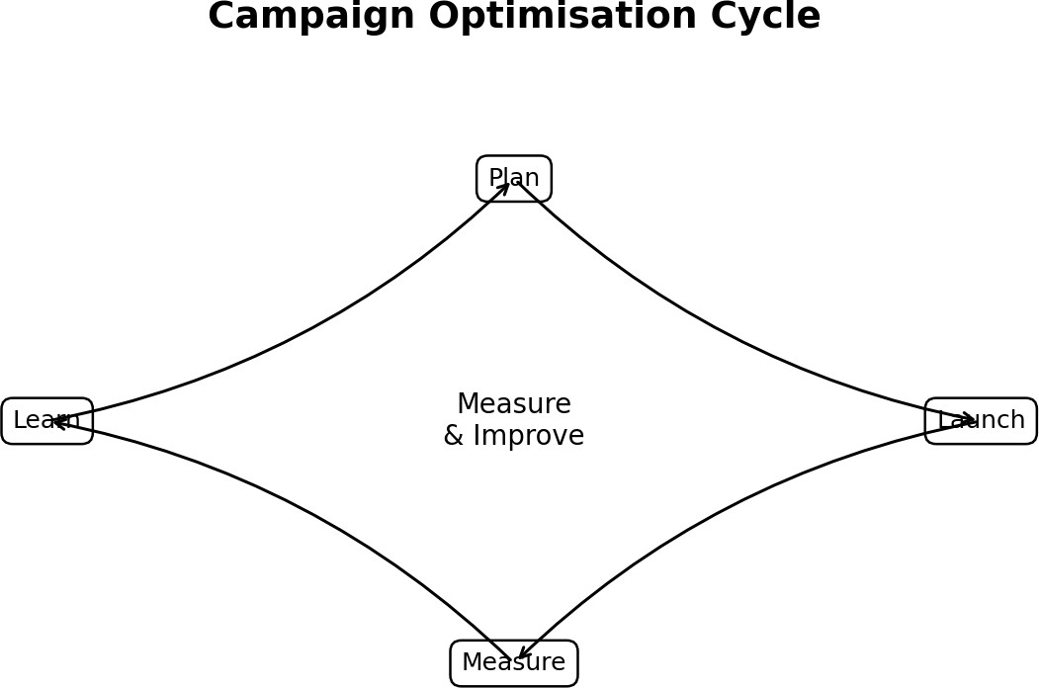

A repeatable campaign system can be organised into four stages: plan, launch, measure and

learn. Planning includes audience and creator selection; launch covers briefing, production and publishing; measurement connects platform data with business outcomes; learning feeds improvements
into the next campaign.

This loop helps the brand move from one-off influencer posts toward a portfolio of creator

relationships and reusable content assets.

CAMPAIGN PHASES

Phase | Activities | Outputs
Phase 1: Setup | Research, goals, creator shortlist | Strategy & briefs
Phase 2: Seeding | Product education, sampling where appropriate | Early content
Phase 3: Launch | Creator publishing and paid amplification | Reach & traffic
Phase 4: Conversion | Offers, retargeting, landing pages | Trials / sales
Phase 5: Retention | Community, education, customer content | Repeat engagement

Sampling should follow product safety, eligibility and disclosure requirements. Creators should not be pressured to claim positive results they did not experience or to make unsupported statements.

INFLUENCER BRIEF TEMPLATE

Brief section | What to include
Campaign goal | One primary objective and supporting objectives
Audience | Segment, need state, language and context
Key message | One clear consumer takeaway
Mandatory facts | Verified product information and permitted claims
Do not say | Unsupported / prohibited claims and risky language
Deliverables | Platform, format, duration, number of posts
Disclosure | Clear sponsorship / paid partnership disclosure
CTA | Landing page, code, education resource or product page
Approval | Review stages, deadlines and responsible contact

CREATOR OUTREACH & RELATIONSHIP MANAGEMENT
Outreach should explain why the creator was selected, what the campaign aims to achieve, what is being requested and how the partnership will be governed. A personalised approach can improve response quality because it demonstrates that the brand understands the creator’s audience.
- Start with relevance rather than follower count.

- Share a concise campaign overview.

- Clarify deliverables, usage rights and timelines.

- Disclose whether content may be paid-amplified.

- Provide claims and compliance guidance early.

- Agree on approval and revision procedures before production.

Long-term relationships can create consistency and reduce repeated onboarding costs, but contracts

should still define deliverables, disclosure, content rights, exclusivity and termination conditions.

STORYTELLING FRAMEWORK
A responsible supplement story can use a simple structure: context → routine → product information → personal perspective → transparent CTA. The creator’s personal experience should
remain clearly personal rather than being framed as a guaranteed result for everyone.

- Hook: identify a relatable routine challenge.

- Context: explain why the creator is discussing the topic.

- Product: show the relevant product information.

- Experience: describe personal use only if genuine.

- Evidence: separate factual product information from opinion.

- CTA: invite the audience to learn more or explore the product.

Avoid fear-based narratives, miracle language, guaranteed outcomes and before/after implications

that could mislead consumers.

DISCLOSURE & COMPLIANCE FRAMEWORK
Influencer advertising should be clearly identifiable as advertising. The brand should maintain a written disclosure standard appropriate to each platform and jurisdiction. In India, brands and creators
should pay particular attention to applicable advertising guidance and sector-specific rules.

- Use clear sponsorship / paid partnership disclosures.

- Keep disclosures prominent and understandable.

- Do not hide disclosures among unrelated hashtags.

- Do not require creators to make claims unsupported by available evidence.

- Maintain records of approved claims and final creative.

- Provide a process for correcting or removing problematic content.

This project is educational and does not constitute legal advice. Before launch, the brand should

obtain current legal / compliance review for the exact product, claims, audience and market.

HEALTH CLAIMS MANAGEMENT

Health supplement marketing requires a claims hierarchy. The safest operational model is to classify statements before they enter creator briefs.

Claim class | Example approach | Approval need
Product fact | Ingredient quantity, format, pack size | Verify against label
Permitted claim | A claim supported and legally usable for the product | Compliance review
Personal experience | Creator describes their own experience | Disclosure + authenticity
Medical / therapeutic claim | Treatment, cure or prevention statement | High-risk; do not use without specific legal basis
Guaranteed outcome | Promises a result for every consumer | Avoid

A claims library should contain the approved wording, source evidence, date reviewed and responsible approver. Creators should receive only the current version.

MEASUREMENT FRAMEWORK
Measurement should connect creator activity to the campaign objective. Vanity metrics can be useful at the awareness stage, but decision-making should progressively include traffic, conversions, economics and retention.

Metric | Formula / interpretation | Use
Engagement rate | Engagements ÷ reach or impressions | Content resonance
CTR | Clicks ÷ impressions | Traffic quality
Conversion rate | Conversions ÷ relevant visits | Landing-page effectiveness
CPA | Spend ÷ conversions | Acquisition efficiency
ROAS | Attributed revenue ÷ ad spend | Revenue efficiency
Repeat rate | Repeat customers ÷ customers | Retention

Attribution windows and platform definitions should be standardised before campaign launch so that results remain comparable.

KPI DASHBOARD

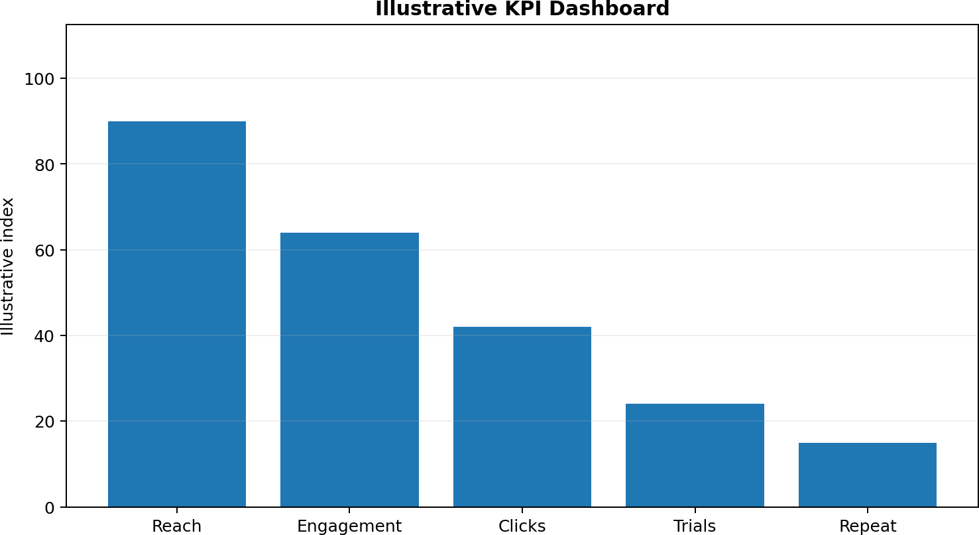
The dashboard above is illustrative. A live dashboard can combine platform analytics, web analytics, affiliate or creator codes, e-commerce orders and customer data. Metrics should be segmented by creator, content format, audience segment and campaign phase.
- Weekly: delivery, reach, engagement, clicks, comments and creative issues.

- Campaign-end: attributed conversions, CPA, revenue and content efficiency.
- Post-campaign: repeat purchase signals, customer quality and creator relationship value.

BUDGET ALLOCATION

Budget area | Illustrative share | Purpose
Creator fees | 35% | Content production and audience access
Paid amplification | 25% | Scale high-performing content
Product / sampling | 10% | Product experience and seeding
Creative production support | 10% | Editing, design and assets
Measurement tools | 8% | Tracking and reporting
Contingency | 7% | Unexpected needs
Compliance / review | 5% | Claims and content review

The percentages are illustrative and should be replaced with actual commercial quotes, product margins and campaign objectives. Budgeting should distinguish fixed creator costs from variable performance costs.

ROI & UNIT ECONOMICS

Influencer marketing should be evaluated alongside product economics. A campaign can generate high engagement but still require optimisation if acquisition costs exceed the brand’s sustainable customer value.

Concept | Illustrative calculation
Gross revenue | Orders × average order value
Gross profit | Revenue − product and fulfilment costs
Contribution after marketing | Gross profit − campaign cost
CPA | Campaign cost ÷ attributed new customers
Estimated LTV | Expected contribution from customer relationship

Attribution should be treated as an analytical model, not absolute truth. Multiple creators may influence the same customer, and platform reporting can differ from first-party records.

TOOLS & TECHNOLOGY STACK

Layer | Typical capability
Creator discovery | Search, audience analysis, creator databases
Campaign management | Briefs, approvals, contracts, deliverables
Tracking | UTM links, creator codes, landing pages
Analytics | Platform analytics, web analytics, e-commerce
Social listening | Comments, mentions, sentiment themes
Reporting | Dashboards and weekly scorecards
Technology should reduce administrative effort while keeping human review for claims, creator suitability and brand safety. Data access should follow applicable privacy and platform requirements.

RISK MANAGEMENT

Risk | Potential impact | Mitigation
Undisclosed sponsorship | Trust / regulatory risk | Mandatory disclosure checklist
Unsupported health claim | Consumer harm / compliance risk | Claims library + review
Creator controversy | Reputation risk | Due diligence + contract clauses
Fake engagement | Wasted spend | Audience / engagement checks
Negative comments | Brand perception | Community response protocol
Platform change | Performance volatility | Diversify channels and creators

A crisis protocol should define who can pause content, who communicates with the creator, who reviews claims and who approves public responses.

ETHICAL CONSIDERATIONS
- Respect consumer autonomy: provide information rather than pressure.

- Be transparent about commercial relationships.

- Do not exploit health anxiety or body-image concerns.

- Do not encourage inappropriate use or dosage.

- Consider vulnerable audiences and avoid targeting that could cause harm.

- Protect creator and customer privacy.

- Correct material misinformation when the brand has contributed to it.

- Use accessible language and avoid unnecessary technical complexity.

Ethical influencer marketing can support long-term trust because audiences increasingly evaluate

not only what a brand sells but also how it communicates.

90-DAY IMPLEMENTATION PLAN

Period | Priority actions | Key outputs
Days 1–15 | Audience research, goals, claims library | Strategy + compliance pack
Days 16–30 | Creator discovery and due diligence | Shortlist + contracts
Days 31–45 | Briefing and content production | Approved creative
Days 46–60 | Launch and early optimisation | Performance report
Days 61–75 | Scale strong creators / formats | Second-wave content
Days 76–90 | Retention and final analysis | Learning report

The plan should remain flexible enough to pause content when creative or compliance concerns arise. The final report should record not only results but also the reasons behind major decisions.

SAMPLE CAMPAIGN CONCEPT
Campaign name: “Make Your Routine Count”

Core idea: creators show how they organise a simple wellness routine while explaining selected product facts in an accessible way. The campaign focuses on consistency and informed choice rather than dramatic transformation.

Asset | Creator type | CTA
30–45 sec routine video | Micro lifestyle | Learn more
Ingredient carousel | Niche educator | Read product facts
Story Q&A | Community creator | Visit FAQ
Long-form explainer | Expert-led creator | Explore evidence / product details
Customer routine UGC | Existing customers | Share your routine

The concept can be localised by language and creator community while keeping the core claims and disclosure standards consistent.

EXPECTED OUTCOMES & LEARNING AGENDA
A strategy document should define what the team wants to learn, not only what it wants to achieve. Early campaigns can test whether creator type, content style, offer and landing-page experience influence audience behaviour.

Learning question | Test | Decision
Which creator type drives qualified traffic? | Compare creator cohorts | Shift future recruitment mix
Which hook improves retention? | A/B test opening formats | Develop creative guidelines
Does education improve conversion? | Educational vs direct-response content | Adjust content mix
Which CTA works best? | CTA variants | Standardise higher-performing CTAs

Results should be interpreted using consistent attribution rules and adequate sample sizes. A single viral post should not automatically become the template for every future campaign.

CONCLUSION
Influencer marketing can become a strategic growth channel for a health supplement brand when it is built around audience relevance, creator fit, responsible communication and measurable business objectives. The most important shift is from one-off sponsored posts toward a managed creator ecosystem.
The proposed framework connects objectives, segmentation, creator selection, content pillars, campaign architecture, disclosure, claims management, measurement, budgeting and optimisation. It also recognises that health-related marketing requires a higher standard of care because audiences may treat creator statements as guidance.
A successful implementation should therefore combine creative freedom with clear boundaries: creators should sound authentic, while product facts, claims, disclosures and legal requirements remain controlled. With disciplined measurement and continuous learning, the brand can build a repeatable influencer program that supports awareness, consideration, trial and retention without relying on exaggerated promises.

Suggested References / Further Reading
- Advertising Standards Council of India (ASCI) — guidance and codes relevant to advertising and influencer disclosures.
- Consumer Protection Act, 2019 (India) — consumer protection and misleading advertising context.
- Relevant Food Safety and Standards Authority of India (FSSAI) regulations and guidance for food
/ health supplement advertising and claims.
- Platform-specific advertising and branded-content policies for the social channels used in a campaign.
- Academic and industry literature on influencer marketing, parasocial interaction, source credibility, consumer trust and digital attribution.

